Rest Dynamic Step

Objective

A RESTAPI defines a set of functions which developers can perform requests and receive responses via HTTP protocol such as GET and POST etc.

In rest dynamic step we can pass the parameters and its values dynamically through a step.

UI

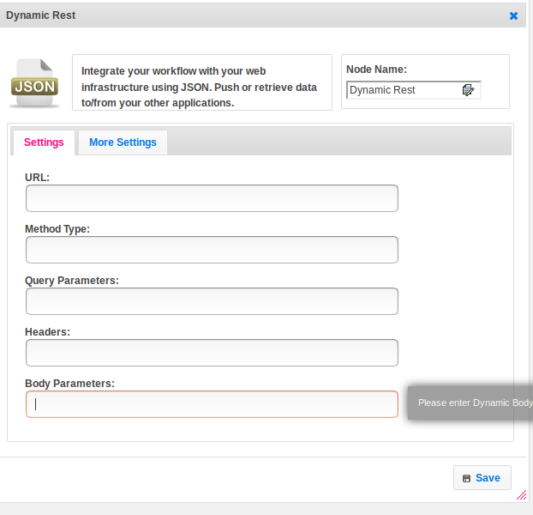

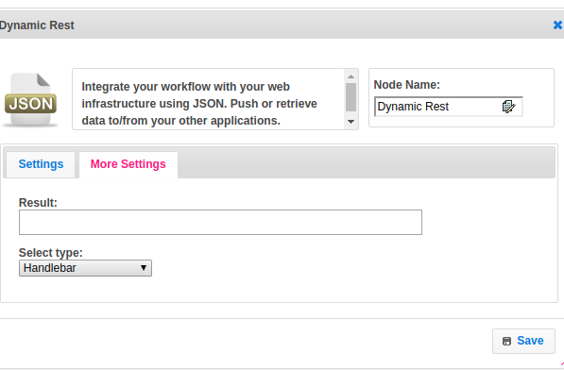

## Attributes

|  |  |
| --- | --- |
| **Attributes** | **Description** |
| **1. URL** | The URL is an essential part of a REST API. |
| **2. Method Type** | Following four HTTP methods are commonly used in REST-based architecture.  GET − Provides read-only access to a resource.  POST − Used to create a new resource.  DELETE − Used to remove a resource.  PUT − Used to update an existing resource or create a new resource. |
| **3. Query Parameters** | The query parameter or query string is the part of a [uniform resource locator](https://en.wikipedia.org/wiki/Uniform_resource_locator) (URL) which assigns values to specified parameters. The query string commonly includes fields added to a base URL |
| **4. Headers** | Parameters included in the request header, usually related to authorization. |
| **5. Body Parameters** | Parameters included in the request body. |
| **6. Result** | Used to store the response of the request. |

## Executor Description

Pass the URL For GET, HEAD, and OPTIONS Dynamically. Build URL For GET, HEAD and OPTIONS requests, parameters will be added to the query string in the requested URL. Add Headers given in the step. Add Post Data. Just set the data which has been given by the user, this data is expected to be JSON data. Set the method. Get Response. Check and assign the response content type. Add response is a string when the content type is JSON / plain text else read bytes and assign.

## Resource

Please refer the below link to get more details.

<https://dzone.com/articles/busy-developers-guide-restful>